Android 2 – Problem Solving Assessment

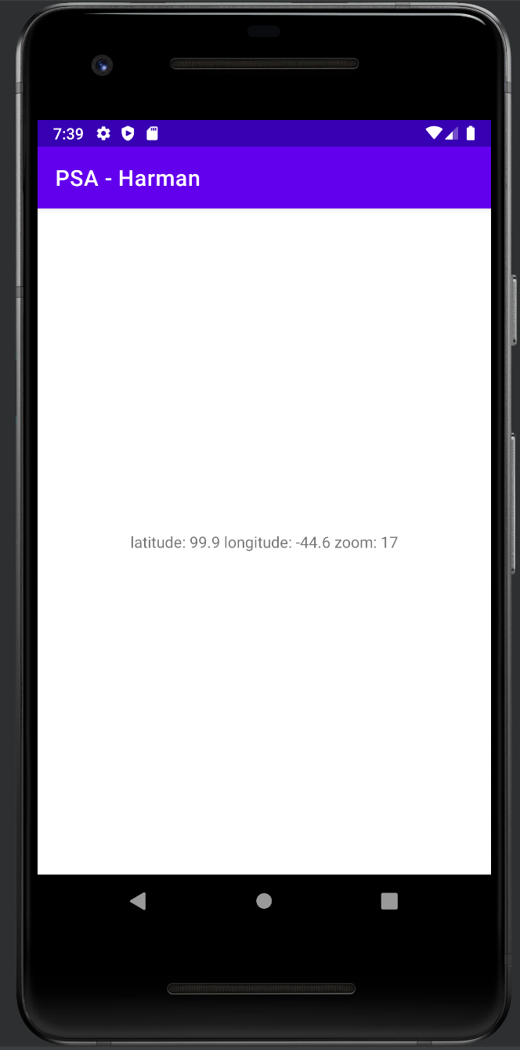

Notes:

The geo is written in string, and I was running into issues trying to set a default location for the emulator – Ill ask about this

package com.example.harman_mann_n01585147_problem_solving_assessment;  
  
import androidx.appcompat.app.AppCompatActivity;  
  
import android.content.Intent;  
import android.net.Uri;  
import android.os.Bundle;  
import android.util.Log;  
import android.view.View;  
import android.widget.Button;  
  
public class MainActivity extends AppCompatActivity {  
  
 Button geo, browser;  
 double latitude, longitude;  
  
 @Override  
 protected void onCreate(Bundle savedInstanceState) {  
 super.onCreate(savedInstanceState);  
 setContentView(R.layout.*activity_main*);  
  
 geo = findViewById(R.id.*btn_geo*);  
 browser = findViewById(R.id.*btn_browser*);  
  
 geo.setOnClickListener(view -> {  
 //trying to implement a way to grab location information for the system  
/* Uri locationURI = getIntent().getData();  
 if (locationURI != null) {  
 String latitudeString = locationURI.getQueryParameter("latti");  
 String longitudeString = locationURI.getQueryParameter("longitude");  
 if (latitudeString != null && longitudeString != null) {  
 latitude = Double.parseDouble(latitudeString);  
 longitude = Double.parseDouble(longitudeString);  
 // Use latitude and longitude here  
 }  
 }*/  
 Intent intent = new Intent(Intent.*ACTION_VIEW*, Uri.*parse*("geo:99.9,-44.6?z=17"));  
 startActivity(intent);  
 });  
  
 browser.setOnClickListener(view -> {  
 Intent intent = new Intent(Intent.*ACTION_VIEW*, Uri.*parse*("https://www.humber.ca"));  
 startActivity(intent);  
 });  
  
  
 }  
}

Manifest

<?xml version="1.0" encoding="utf-8"?>  
<manifest xmlns:android="http://schemas.android.com/apk/res/android"  
 xmlns:tools="http://schemas.android.com/tools">  
 <uses-permission android:name="android.permission.ACCESS_FINE_LOCATION"/>  
 <uses-permission android:name="android.permission.ACCESS_COARSE_LOCATION"/>  
 <uses-permission android:name="android.permission.INTERNET" />  
  
 <application  
 android:allowBackup="true"  
 android:dataExtractionRules="@xml/data_extraction_rules"  
 android:fullBackupContent="@xml/backup_rules"  
 android:icon="@mipmap/ic_launcher"  
 android:label="@string/app_name"  
 android:supportsRtl="true"  
 android:theme="@style/Theme.Harman_Mann_N01585147_Problem_Solving_Assessment"  
 android:usesCleartextTraffic="true"  
 tools:targetApi="31">  
 <activity  
 android:name=".BrowserActivity"  
 android:exported="true">  
 <intent-filter>  
 <action android:name="android.intent.action.VIEW"/>  
 <data android:scheme="https" android:host="www.humber.ca" />  
 <data android:scheme="http" android:host="www.humber.ca" />  
 <category android:name="android.intent.category.DEFAULT" />  
 <category android:name="android.intent.category.BROWSABLE" />  
 </intent-filter>  
 </activity>  
 <activity  
 android:name=".MapViewActivity"  
 android:exported="true" >  
 <intent-filter>  
 <action android:name="android.intent.action.VIEW" />  
 <data android:scheme="geo" />  
 <category android:name="android.intent.category.DEFAULT" />  
 </intent-filter>  
 </activity>  
 <activity  
 android:name=".MainActivity"  
 android:exported="true">  
 <intent-filter>  
 <action android:name="android.intent.action.MAIN" />  
 <category android:name="android.intent.category.LAUNCHER" />  
 </intent-filter>  
 </activity>  
 </application>  
  
</manifest>

Main activity

package com.example.harman_mann_n01585147_problem_solving_assessment;  
  
import androidx.appcompat.app.AppCompatActivity;  
  
import android.content.Intent;  
import android.net.Uri;  
import android.os.Bundle;  
import android.util.Log;  
import android.view.View;  
import android.widget.Button;  
  
public class MainActivity extends AppCompatActivity {  
  
 Button geo, browser;  
 double latitude, longitude;  
  
 @Override  
 protected void onCreate(Bundle savedInstanceState) {  
 super.onCreate(savedInstanceState);  
 setContentView(R.layout.*activity_main*);  
  
 geo = findViewById(R.id.*btn_geo*);  
 browser = findViewById(R.id.*btn_browser*);  
  
 geo.setOnClickListener(view -> {  
 //trying to implement a way to grab location information for the system  
/* Uri locationURI = getIntent().getData();  
 if (locationURI != null) {  
 String latitudeString = locationURI.getQueryParameter("latti");  
 String longitudeString = locationURI.getQueryParameter("longitude");  
 if (latitudeString != null && longitudeString != null) {  
 latitude = Double.parseDouble(latitudeString);  
 longitude = Double.parseDouble(longitudeString);  
 // Use latitude and longitude here  
 }  
 }*/  
 Intent intent = new Intent(Intent.*ACTION_VIEW*, Uri.*parse*("geo:99.9,-44.6?z=17"));  
 startActivity(intent);  
 });  
  
 browser.setOnClickListener(view -> {  
 Intent intent = new Intent(Intent.*ACTION_VIEW*, Uri.*parse*("https://www.humber.ca"));  
 startActivity(intent);  
 });  
  
  
 }  
}

mapping

package com.example.harman_mann_n01585147_problem_solving_assessment;  
  
import androidx.appcompat.app.AppCompatActivity;  
import androidx.core.app.ActivityCompat;  
  
import android.content.Context;  
import android.content.pm.PackageManager;  
import android.location.Location;  
import android.location.LocationManager;  
import android.os.Bundle;  
import android.view.View;  
import android.widget.TextView;  
  
import java.util.ArrayList;  
  
public class MapViewActivity extends AppCompatActivity {  
 TextView geoText;  
  
 @Override  
 protected void onCreate(Bundle savedInstanceState) {  
 super.onCreate(savedInstanceState);  
 setContentView(R.layout.*activity_map_view*);  
 geoText = findViewById(R.id.*geoText*);  
 String[] geo = getIntent().getData().toString().split("[:,?]");  
 String result = "";  
 if (geo.length == 3) {  
 result = "latitude: " + geo[1] + " longitude: " + geo[2];  
 } else if (geo.length == 4) {  
 result = "latitude: " + geo[1] + " longitude: " + geo[2] + " zoom: " + geo[3].split("=")[1];  
 } else {  
 result = "Empty Geo Info";  
 }  
 geoText.setText(result);  
 }  
}

Browser Activity

package com.example.harman_mann_n01585147_problem_solving_assessment;  
  
import androidx.appcompat.app.AppCompatActivity;  
  
import android.os.Bundle;  
  
public class BrowserActivity extends AppCompatActivity {  
  
 @Override  
 protected void onCreate(Bundle savedInstanceState) {  
 super.onCreate(savedInstanceState);  
 setContentView(R.layout.*activity_browser*);  
 getSupportFragmentManager()  
 .beginTransaction()  
 .replace(R.id.*wv_container*, new WV_Fragment(getIntent().getData().toString())).commit();  
  
 }  
}

webview fragment

package com.example.harman_mann_n01585147_problem_solving_assessment;  
  
import android.os.Bundle;  
  
import androidx.fragment.app.Fragment;  
  
import android.view.LayoutInflater;  
import android.view.View;  
import android.view.ViewGroup;  
import android.webkit.WebView;  
  
public class WV_Fragment extends Fragment {  
 String url;  
 public WV_Fragment(String url) {  
 this.url = url;  
 }  
  
 @Override  
 public void onViewCreated(View view, Bundle savedInstanceState) {  
 WebView webView = requireView().findViewById(R.id.*wv*);  
 webView.loadUrl(url);  
 }  
  
 @Override  
 public View onCreateView(LayoutInflater inflater, ViewGroup container,  
 Bundle savedInstanceState) {  
 // Inflate the layout for this fragment  
 return inflater.inflate(R.layout.*fragment_w_v_*, container, false);  
 }  
}